Week 7 Work Log: Continuous Feedback and Project Performance Reporting

Complete this worksheet as a team during or after the Week 7 workshop. Add more rows if needed.

Group | Forecasting 4 | Workshop | Thursday 3:30pn – 5:30pm
Project title | Forecasting Model Development AI-Powered Energy Prediction | Date | September 24th
Client | ARC Research Hub for Integrated Energy Storage Solutions | Members present | Yaqiao, Bhumika

  - Activity 1 Current state assessment and gap analysis
List every end objective from your plan, then state honestly where each stands today. A gap is the distance between the two; the action is what closes it. Then sort the gaps by kind - knowing whether a gap is about skills, resources, execution or communication tells you who can fix it.

End objective | Current status | Identified gap | Action to close it | Resources needed | Timeline
O1: Train an XGBoost baseline model | Done. MAE = 335.78MW, RMSE = 451.25MW, MAPE = 1.066% | Results are only from PJM. Not yet tested on Household Electric Power Consumption. | Run the same XGBoost code on the cleaned Household Electric Power Consumption dataset. | Cleaned Household Electric Power Consumption data, Python, Colab | Completed on September 18-20th
O2: Train an LSTM model | Done. MAE = 245.66MW, RMSE = 331.95MW, MAPE = 0.783%, outperforming the XGBoost baseline. | None | N / A | N / A | Completed on September 24-25th
O3: Compare XGBoost and LSTM | Done. Combined both models using error-reciprocal weighting (LSTM weight 0.578, XGBoost weight 0.422), giving a hybrid model with MAE=241.58 MW, RMSE=323.07MW, MAPE=0.764%, the best result so far. | None | N / A | N / A | Completed on September 24-25th
O4: Add SHAP and LIME explanations | Done. Applied SHAP to the XGBoost model and LIME to the LSTM model, each explaining three individual predictions. Both methods agree that the most recent 1-2 hours are the strongest predictors. | None | N / A | N / A | Completed on September 24-25th
O5: Write a plain-English summary | Not started | We have no report template for non-technical users. | We will write a one-page summary after the SHAP results are ready. | Word or Markdown template | Week 8

Knowledge gaps | Resource gaps | Execution gaps | Communication gaps
LSTM implementation gap has been closed.  Remaining gap: writing a plain-English summary for non-technical stakeholders. | We only have two active members, Vidhi and Marwa have not contributed since Week 3. | Cross-dataset validation (Household Electric Power Consumption) has not started. | The two active members talk every week. But we have no contact with the two inactive members.

  - Activity 2 Action plan to close gaps
Plan the highest-priority gaps first. Swap sheets with a neighbouring team and have them fill the peer feedback column before you finalise.

Gap | Action steps | Responsible | Timeline | Resources | Priority (H/M/L) | Peer feedback
LSTM is not started (Completed) | 1. Built and trained LSTM on Colab  2. XGBoost into a hybrid model | Yaqiao | Completed September 24-25th | Colab T4 GPU | H | Bhumika
XGBoost only tested on PJM | 1. Load the cleaned Household Electric Power Consumption data.  2. Run the same XGBoost code.  3. Record MAE, RMSE, MAPE. | Bhumika | Week 8-9 | Household Electric Power Consumption data, Python | M | Yaqiao
No interpretability code (Completed) | Applied SHAP to XGBoost and LIME to LSTM, explaining three predictions each | Yaqiao | Completed September 24-25th | SHAP, LIME | H | Bhumika
No plain-English summary | 1. Write a one-page summary.  2. Avoid technical words.  3. Share with team members. | Yaqiao, Bhumika | Week 9-10 | Report template | M | Yaqiao, Bhumika, and tutor
Two members are inactive | 1. Keep records of no response.  2. Report to the tutor again.  3. Adjust the plan for two people. | Yaqiao | Ongoing | Weekly worklog, MS Teams | M | Yaqiao, Bhumika, and tutor

  - Activity 3 Progress monitoring and performance report
Run a checkpoint on your gap-closing actions and describe how feedback will keep reaching you. Then put numbers on progress using real data from your board or work log, with the same unit for planned and completed work. An SPI below 1.0 means you are behind schedule - say so plainly rather than explaining it away.

Who gives feedback, and how often | Mr. Fusen  Every Thursday workshop | Team members (Yaqiao, Bhumika)  Every week
Where it is captured (board, issue tracker, minutes) | Worklogs, workshop | MS Teams, GitHub, Jira
How it reaches the backlog and changes the build | We adjust tasks and priorities each week | We update the backlog and task owners each week
Checkpoint result: on track / needs adjustment / needs resources | Needs adjustment. | On track. LSTM, hybrid model, and interpretability analysis are all complete, ahead of the original timeline. XGBoost’s cross-dataset validation and the plain-English summary remain outstanding.

Measure | Value (state the unit) | Where the number came from
Planned work units (PW) | 5 objectives (O1-O5) | This week’s Activity 1 table
Completed work units (CW) | 4 (O1, O2, O3, O4 done; O5 not started) | Activity 1 table above
Planned time to date (PT) | 168 hours | 6 hrs/week * 4 members (original team) * 7 weeks
Actual time spent (AT) | 72.5 hours | Yaqiao: 44.5h (Weeks 1-7).  Bhumika: 28h (Weeks 1-7)

Metric | Formula | Result | What it tells you about your project
Schedule variance (SV) | CW - PW | 4 – 5 = -1 | We are only 1 objective short of full completion, a small and manageable gap.
Schedule performance index (SPI) | CW / PW | 4 / 5 = 0.80 | An SPI of 0.80 shows we are close to on schedule, since 1.0 represents being perfectly on track.
Resource utilisation efficiency (RUE) | PW / AT | 5 / 72.5 = 0.069 | Actual hours (72.5h) are well below the originally planned 168 hours, mainly because Vidhi and Marwa have not contributed at all. Despite this, the two active members still completed 4 of 5 objectives, showing that the work that was done was done efficiently.

Performance summary for the client, as you would actually report it | We have finished the data cleaning, the XGBoost baseline (MAE = 335.78 MW, RMSE = 451.25 MW, WAPE = 1.066%), the LSTM model (MAE = 245.66 MW, RMSE = 331.95 MW, MAPE = 0.783%), and a hybrid model combining both using error-reciprocal weighting (MAE = 241.58 MW, RMSE = 323.07MW, MAPE = 0.764%, our best result so far).  We have also completed SHAP and LIME interpretability analysis on both models, which agree that the most recent 1-2 hours are the strongest predictors of demand. The remaining work is testing on a second dataset and preparing a plain-English summary for non-technical stakeholders.”

Contribution register

Every member completes at least one row in their own words. Mark each task M for management (planning, client contact, minutes, scheduling, risk, document control) or T for technical (research, requirements drafting, design, prototyping, testing, tooling). Evidence must be something the tutor can open; rows without evidence do not count.

Member name | Task / activity completed this week | Type (M / T) | Evidence (link, file, commit, minutes) | Time spent (hrs)
Yaqiao Chi | 1. Built and trained the LSTM model;  2. Combined LSTM and XGBoost into a hybrid model using error-reciprocal weighting;  3. Applied SHAP to the XGBoost model and LIME to the LSTM model, explaining three predictions each;  4. Saved all work to GitHub | M & T | GitHub: https://github.com/Yaqiao-chi-helen/Forecasting-team4/blob/main/notebooks/Model_Development_XGBoost_LSTM.ipynb  LSTM Model:  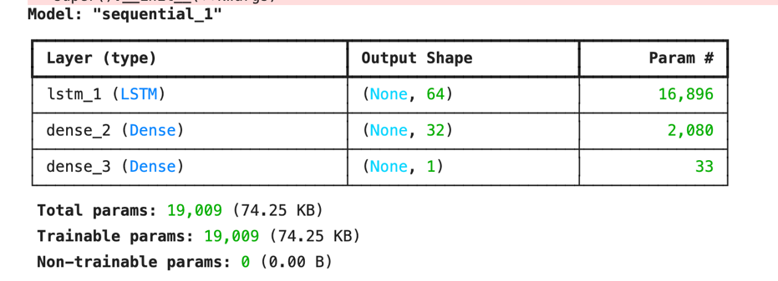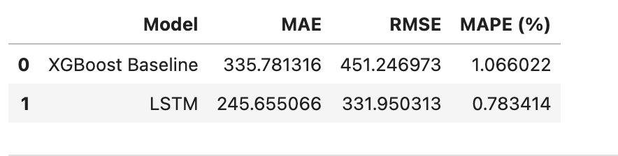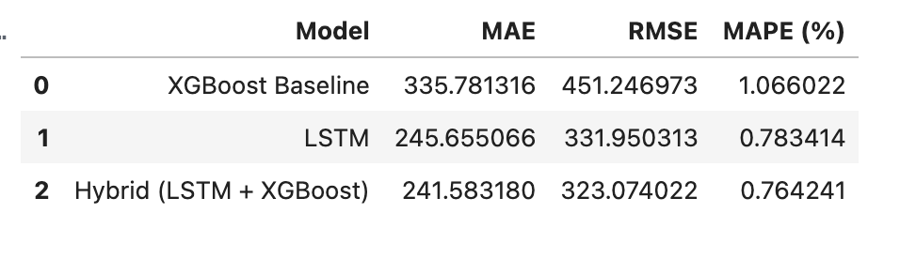  SHAP for XGBoost model:  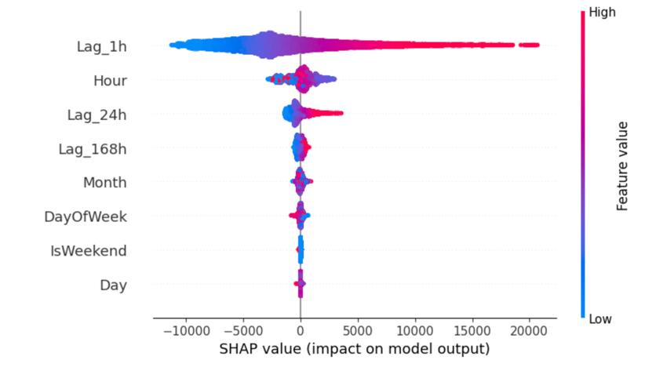  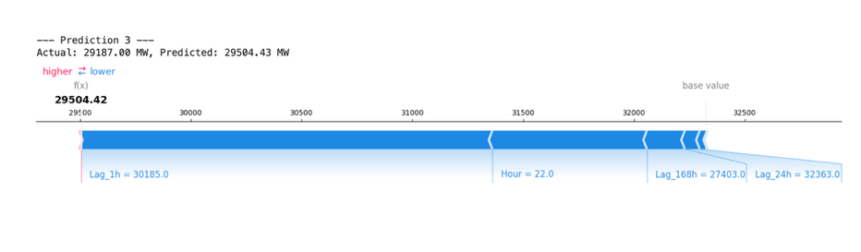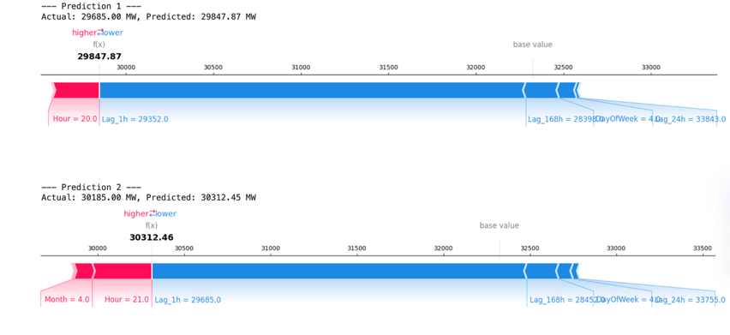  LIME:  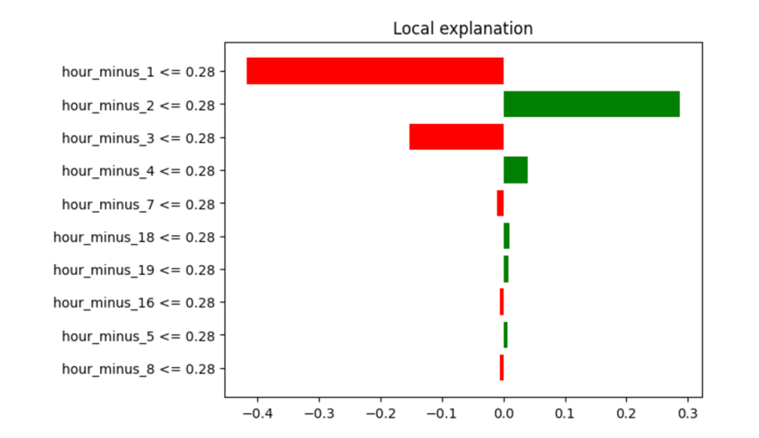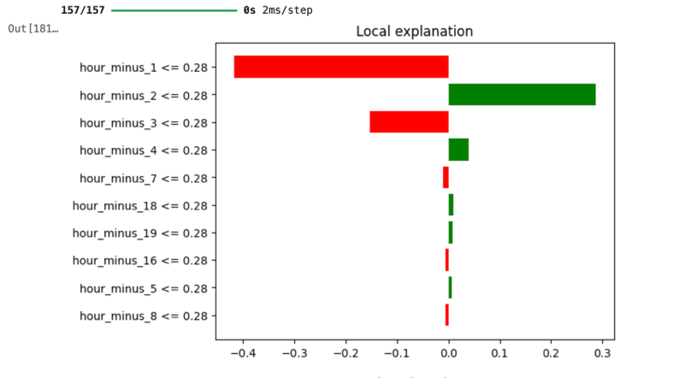 | 11 h
Bhumika Sharma | 1. Completed initial EDA on the cleaned PJM dataset, including dataset checks, descriptive statistics and demand visualisation. 2. Performed time-based feature engineering (Hour, Day, Month, DayOfWeek, IsWeekend) and lag feature engineering (Lag_1h, Lag_24h, Lag_168h). 3. Prepared the chronological training/testing split and preprocessing for the forecasting model. 4. Set up TensorFlow/Keras in Google Colab. 5. Built, trained and evaluated the XGBoost baseline using MAE, RMSE and MAPE. | M & T | 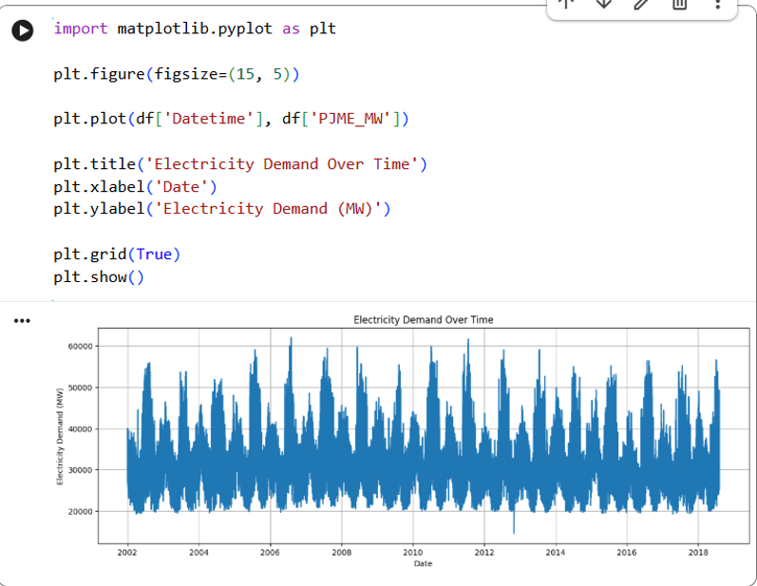Time graph depicts substantial variation in electricity demand across the observation period, with recurring peaks and lower-demand periods  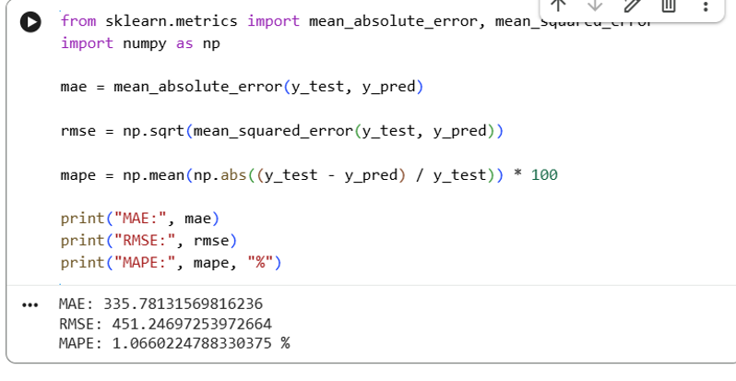Observations according to the cleaned dataset. | 8hr
Vidhi Patel | No contribution this week | N / A | N / A | N / A
Marwa Aldhafeeri | No contribution this week | N / A | N / A | N / A

Agreed actions for the coming week

Owner | Action to complete before next workshop | Due date
Bhumika | Run XGBoost on the cleaned Household Electric Power Consumption dataset | Week 8
Yaqiao | Write a plain-English summary of results for non-technical stakeholders | Week 8-9
Yaqiao | Complete the data cleaning for the remaining two datasets | Next Wednesday (September 30th)
Yaqiao | Follow up with the tutor about Vidhi and Marwa’s contribution status | Next Thursday

Anything blocking the team, or any contribution imbalance the tutor should know about?

One team member (Bhumika) experienced a personal emergency this week, because of which, she couldn’t attend the weekly meeting. We will check in with her and adjust task ownership if needed, without adding pressure while she recovers.

Separately, Vidhi and Marwa have made zero contributions since Week 3, with no workshop attendance, this has already been escalated to the tutor and we will continue to monitor it.

